**INT - 301: OPEN SOURCE TECHNOGOLIES**

**A Project Report**

# BTech [Computer Science Engineering (Hons.)]

**Lovely Professional University Phagwara, Punjab.**

**Submitted by:**

**Name of the Student:**Ram Agrawal

**Registration Number:**11911580

**Roll No:**23

**Section:** KE059

**Submitted to:**

**Manpreet Singh (23789)**

**Q - 22 🡪 Use any open source software to extract addons, bookmarks, cookies, downloads, form fillups data, history from your browser and export the data obtained after extraction either in a JSON file or plain text file**.

ANS –

**INTRODUCTION**

A bookmark in Mozilla Firefox is a way of saving a website address (URL) for future reference. When you bookmark a page in Firefox, you create a shortcut to that page, which you can then access from the bookmarks toolbar or menu.

Bookmarks can help you save time by allowing you to quickly access your favorite websites without having to type in the URL each time. They also make it easier to organize and categorize your favorite sites, so you can find them more easily.

We have used Jason in order to find the cookies , download , form fill up and history using extract Jason and extracted by bookmark.

**DESCRIPTION**

A bookmark is a saved shortcut to a webpage that allows you to quickly access the webpage without having to remember or type in the full URL. When you bookmark a webpage, you create a link to it that is saved in your web browser for easy access later on.

Bookmarks are a useful tool for organizing your favorite websites or webpages that you visit frequently, as they provide quick access to these sites with just a few clicks. They can also help you keep track of important pages that you need to refer back to later.

**SYSTEM DESCRIPTION**

The system dependency of bookmarks can also be affected by the operating system being used. For instance, some browsers may be optimized for a particular operating system, such as Chrome for Windows or Safari for macOS, and their bookmarking features may function differently or have different user interfaces across operating systems.

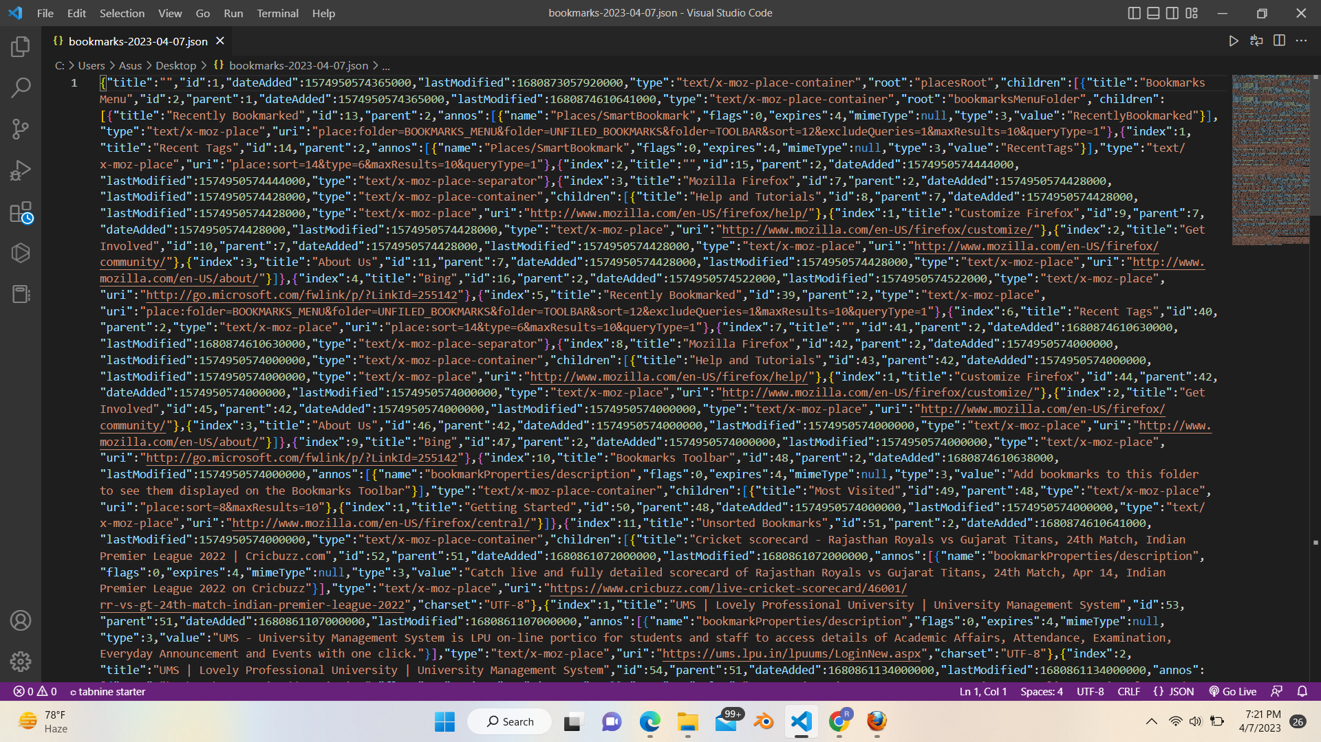

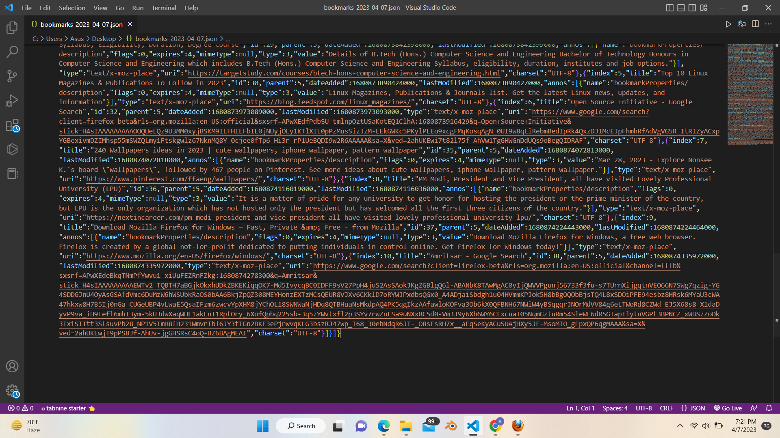

This is in the Jason file format where the code is being written in Jason language and the code in being written Jason file.

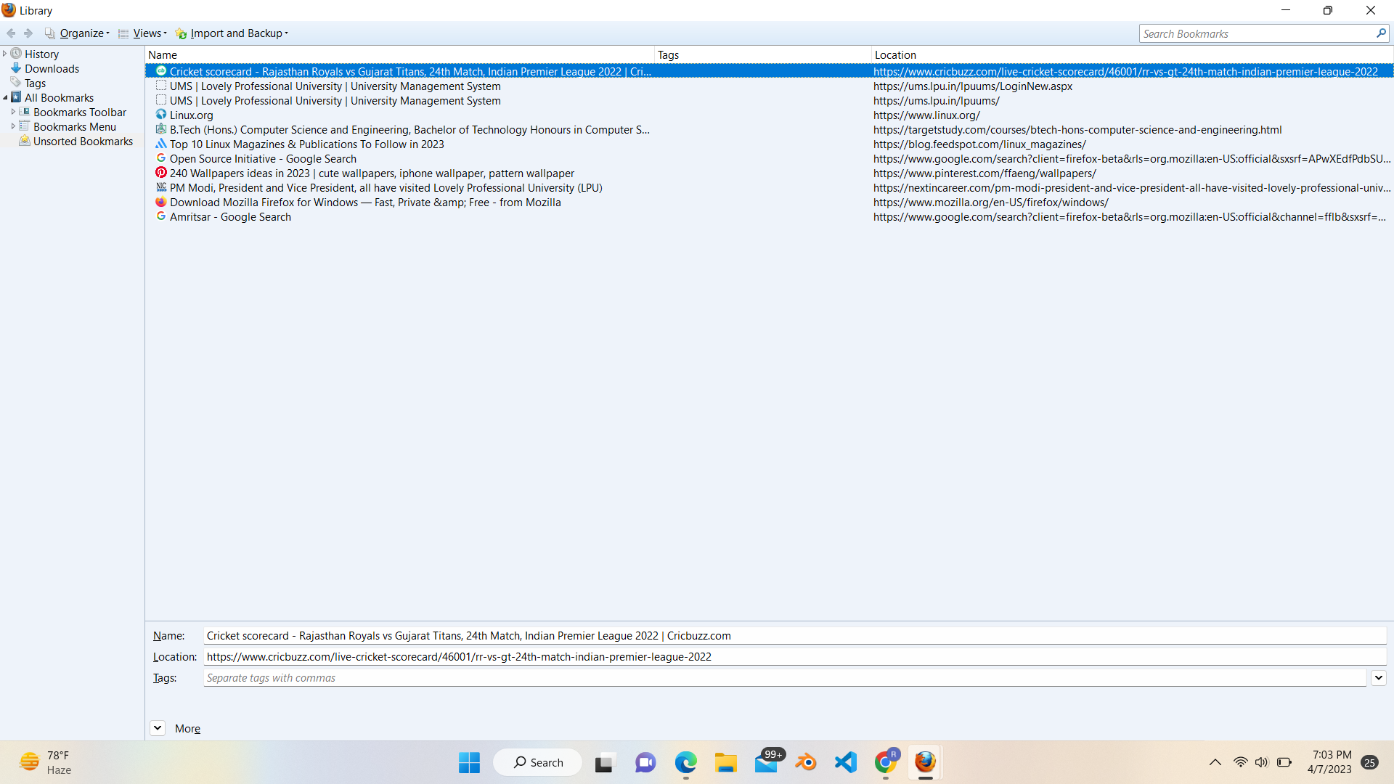

The bookmark of the library in mozila firefox

Bookmark toolbar where all the site are being there and there decription written on it

The downloads of the li brary of the bookmark in the give visited sites used by user .

**REFERENCE / BIBLOGRAPHY**

1. <https://adloop.co/en/marketing-data-extraction-with-adloop/#:~:text=Why%20is%20Data%20Extraction%20important,and%20efficiently%20with%20marketing%20teams>.

2 ) <https://www.talend.com/resources/data-extraction->